**PROJECT REPORT**

**ON**

**Smart bottle in health care**



DHARMSINH DESAI UNIVERSITY

FACULTY OF TECHNOLOGY

DEPARTMENT OF ELECTRONICS AND COMMUNICATION

PREPARED BY: GUIDED BY:

Ankit Dobariya (EC-004), Sem 6 Prof. Manish.k.Patel

Rahul Baldaniya (EC-005), Sem 6

CERTIFICATE

This is to certify that the project on **smart bottle in health care** and term work carried out in the subject of Term Project is bonafide work of **ANKIT DOBARIYA** (Roll no.: **EC-013**) and **RAHUL BALDANIYA** (Roll no.: **EC-004**) of B. Tech. semester 6th in the branch of **Electronics & Communication**, during the academic year 2019-20.

|  |  |
| --- | --- |
| Prof. Manish.k.Patel | Dr. Nikhil J. Kothari |
| Project Guide, EC Dept. | HOD, EC Dept. |

ACKNOWLEDGEMENT

It is pleasant task to express our gratitude to all those who have accomplished and helped us in this work.

First and foremost, we take this opportunity to express deep sense of gratitude to our guide Prof. Manish.k.Patel, Department of Electronics and Communication, Dharmsinh Desai University, Nadiad, for his valuable suggestions and encouragement throughout the project which helped us a lot to improve this project work. We are also indebted to Dr. Nikhil J. Kothari, HOD of Electronics and Communication, Dharmsinh Desai University, Nadiad, for their kind help and co-operation during this work. Last but not least, we extend our thanks and appreciation to our friends, colleagues, batch-mates and everyone who have helped us directly or indirectly to get this work done. ABSTRACT

In today’s world, there is a continuous need for automatic as well as portable appliances with increase in standard of living. We designed a device which can be used in a less space of work and also it is more efficient in medical sector. Thus we have come up with an idea and designed a device which can be fitted with the botttle and is safe as well as portable.

This device provide us with the alert message which is feeded into the registered mobile number of doctor & nurse. So that an immediate action can be taken and to avoid any cause to the patient.

Our main heart of the project is the microcontroller which we are using of (80 family),through which our weight sensor (HX711),load cell which is been attached to a wooden board and a GSM module. At last by discussing with our colleagues and professor we come up with this project and some components which is proper suitable to our application.

**INDEX**

|  |  |  |
| --- | --- | --- |
| **Sr. No.** | **Title** | **Page No.** |
|  |  |  |
| 1 | Introduction | 6 |
|  |  |  |
| 2 | Block Diagram | 7 |
|  |  |  |
| 3 | Circuit Diagram | 8 |
|  |  |  |
| 4 | Component Description | 9 |
|  |  |  |
| 5 | Working of Circuit | 14 |
|  |  |  |
| 6 | Practical Setup and Trouble Shooting | 15 |
|  |  |  |
| 7 | Conclusion | 16 |
|  |  |  |
| 8 | References | 16 |
|  |  |  |

**1. INTRODUCTION**

For the safety of the Patient which are been diagnosed in the hospitals due to the cause of severe diseases and day to day occurring health problems. Our main goal is to prevent the accidents which are been occurring mainly in big hospitals and government hospitals due to the nurses or doctors when the patient as to deal with bottles in which the content of the bottle is been injected in the patients body.

Many times the patient is been unconscious lying in the bed and as soon as the bottle gets empty the particular nurse has to change or replace the bottle. If they are busy with any reason or they forgot to do it then patient might get in trouble so to prevent from that we have made a portable device which can be connected with the patients bottle.

Our device consists of a microcontroller (8052), weight sensor (HX711), load cell, GSM module, connecting wires, and piece of wooden board on which the bottle is been hold. The working is like the load cell measures the weight of the bottle and passes the analog data to the HX711 weight sensor, which converts the data to the digital form and is feeded to the 8052 microcontroller and our GSM module is also connected with the microcontroller.

When the bottle as only the 10-20% of the content in it the weight sensor passes the parallel output as the input of microcontroller and as per the function of the code it feeds the GSM module and the written message is sended to the given registered number.

**2. BLOCK DIAGRAM**

8

0

5

2

Micro-controller

**HX711 IC**

GSM

Module

SIM 900

4. **COMPONENTS AND IT’S DESCRIPTION**

**(4.1) 8052 Microcontroller**

8052 has all the standard features of the 8051 microcontroller as well as an extra 128 bytes of RAM and an extra timer. It also has 8K bytes of on-chip program ROM instead of 4K bytes.

An 8051/8052 microcontroller comes bundled with the following features:-

* 4KB bytes on-chip program memory (ROM)
* 128 bytes on-chip data memory (RAM)
* Four register banks
* 128 user defined software flags
* 8-bit bidirectional data bus
* 16-bit unidirectional address bus
* 32 general purpose registers each of 8-bit
* 16 bit Timers (usually 2, but may have more or less)
* Three internal and two external Interrupts
* Four 8-bit ports,(short model have two 8-bit ports)
* 16-bit program counter and data pointer
* 8051 may also have a number of special features such as UARTs..

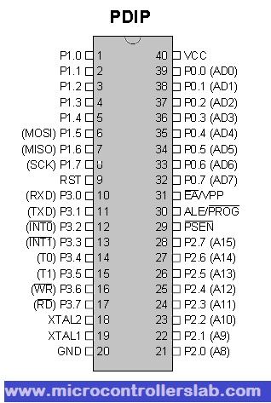

**(4.2) HX711 IC**

HX711 is a16 pin device and has a precision 24-bit analog to digital converter (ADC) designed for weigh scales and industrial control applications to interface directly with a bridge sensor. To measure weight using load cell we usually need-regulated power source, output amplifier (noise reduced), ADC converter. All three features need three separate circuits and components adding to cost and complexity.  So we can use **HX711 IC** which has all the above features simply removing complex circuit.

OVERALL FEATURES • Two selectable differential input channels • On-chip active low noise PGA with selectable gain of 32, 64 and 128 • On-chip power supply regulator for load-cell and ADC analog power supply • On-chip oscillator requiring no external component with optional external crystal • On-chip power-on-reset • Simple digital control and serial interface: pin-driven controls, no programming needed • Selectable 10SPS or 80SPS output data rate • Simultaneous 50 and 60Hz supply rejection • Current consumption including on-chip analog power supply regulator: normal operation < 1.5mA, power down < 1uA • Operation supply voltage range: 2.6 ~ 5.5V • Operation temperature range: -40 ~ +85℃ • 16 pin SOP-16 package

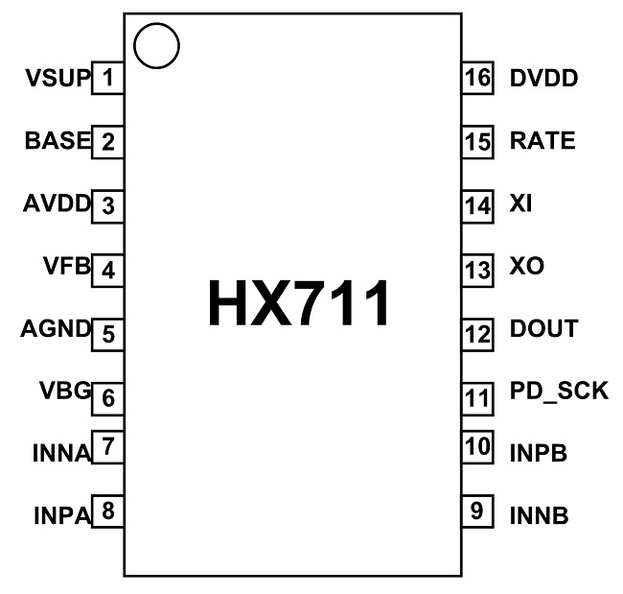

**(4.3) load cell [Double ended]**

A load cell is a type of transducer, specifically a *force* transducer. It converts a force such as tension, compression, pressure, or torque into an electrical signal that can be measured and standardized. As the force applied to the load cell increases, the electrical signal changes proportionally. The most common types of load cell used are hydraulic, pneumatic, and strain gauge.

Common specifications include:

* Full Scale Output (FSO): Electronic output expressed in mv/V. Measured at full scale.
* Combined Error: % of the full scale output that represents the maximum deviation from the straight line drawn between no load and load at rated capacity. Often measured during decreasing and increasing loads.
* Non-Linearity: The maximum deviation of the calibration curve from a straight line drawn between the rated capacity and zero load. Measured on increasing load and expressed as % of full scale output.
* Hysteresis: Maximum difference between load cell output signals for the same applied load. The first measurement can be obtained by decreasing the load from rated output and the second by increasing the load from zero.
* Repeatability: Maximum difference between output measurements for repeated loads under identical conditions. Measured in % of rated output.
* Zero Balance (Offset): Output reading of the load cell with rated excitation under no load. The deviation in output between a true zero measurement and a real load cell under zero load expressed as a percentage of full scale output.

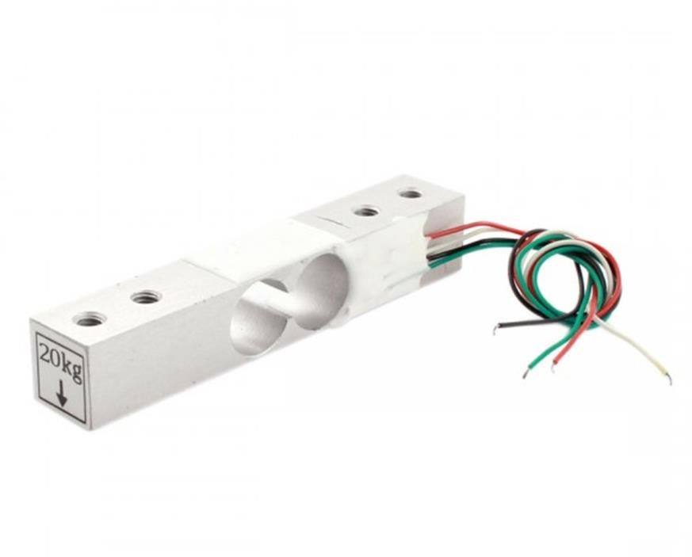

**(4.4) RESISTORS**

A resistor is a passive two-terminal electrical component that implements electrical resistance as a circuit element. Resistors act to reduce current flow, and, at the same time, act to lower voltage levels within circuits. In electronic circuits, resistors are used to limit current flow, to adjust signal levels, bias active elements, and terminate transmission lines among other uses. Here we are using the resistors of value 220 **Ω**, 1K **Ω**.

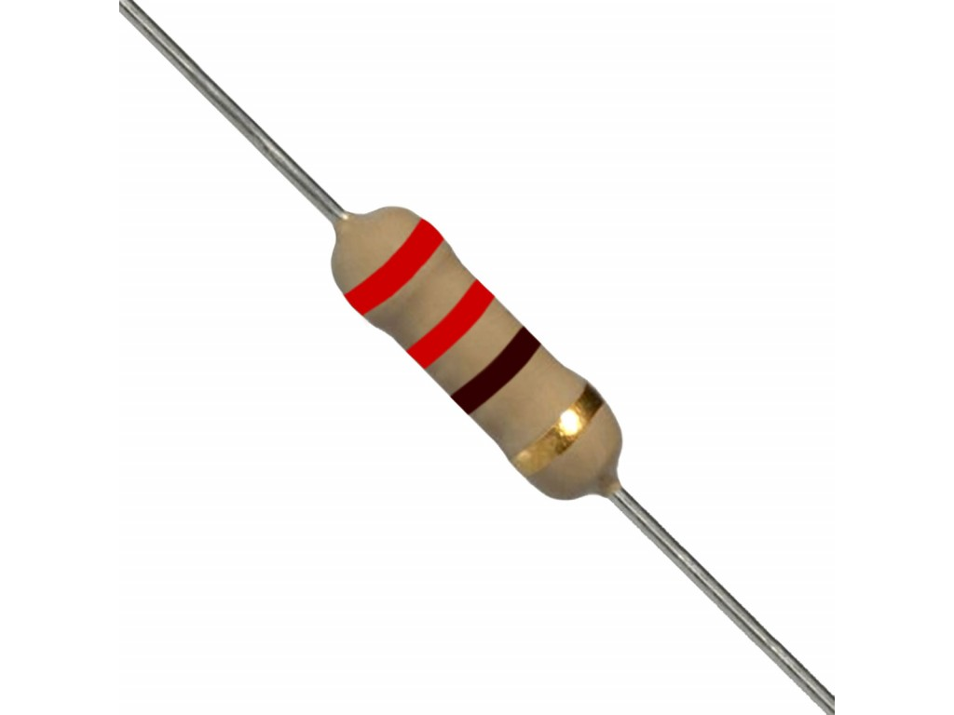

**(4.5) GSM Module**

A GSM module is a chip or circuit that will be used to establish communication between a mobile device or a computing machine and a GSM system. The modem (modulator-demodulator) is a critical part of here.

These modules consist of a GSM module powered by a power supply circuit and communication interfaces for computer. A GSM modem can be dedicated modem device with a serial, USB or Bluetooth connection, or it can be a mobile phone that provides GSM modem capabilities.

Wireless modems generate, transmit or decode data from a cellular network, in order to establish communication.

A GSM modem is a class of wireless modem, designed for communication over the GSM. It requires a SIM card just like mobile phones to activate communication with the network. Also they have IMEI number similar to mobile phones for their identification.

1. The MODEM needs [AT commands](https://www.electronicsforu.com/resources/cool-stuff-misc/wanted-know-gsm-commands), for interacting with processor or controller, which are communicated through serial communication.
2. These commands are sent by the controller/processor.
3. The MODEM sends back a result after it receives a command.
4. Different AT commands supported by the MODEM can be sent by the processor/controller/computer to interact with the GSM and GPRS cellular network.

**Functions include:**

* Read, write and delete SMS messages.
* Send SMS messages.
* Monitor the signal strength.
* Monitor the charging status and charge level of the battery.
* Read, write and search phone book entries.

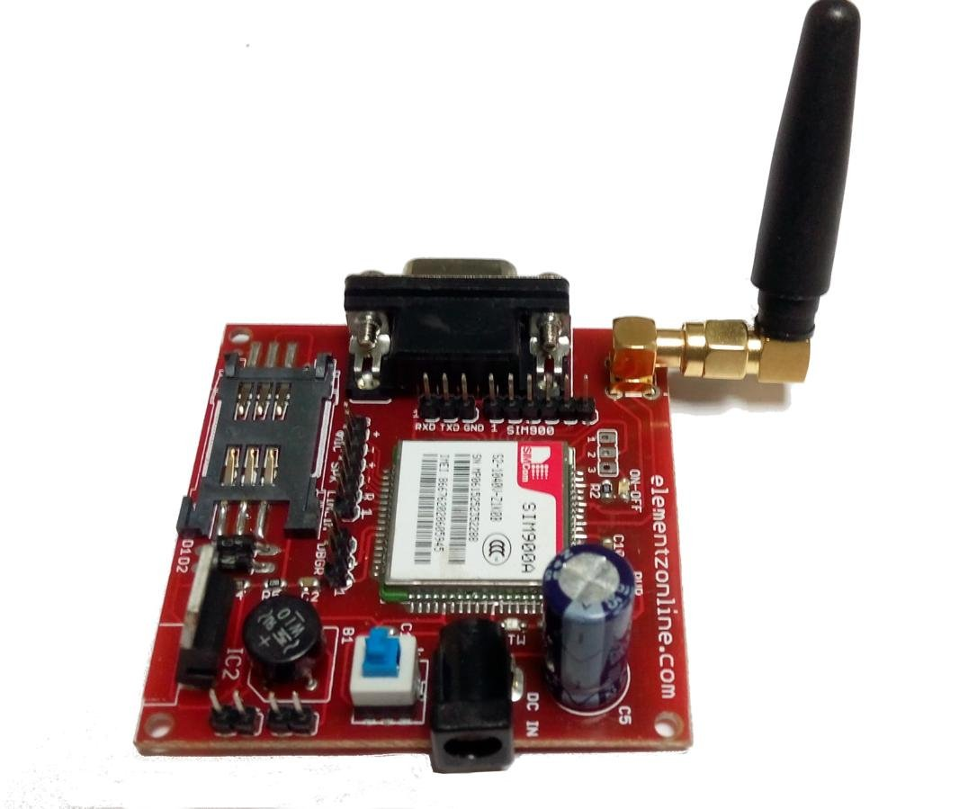

1. **WORKING OF CIRCUIT**

Basically the body of the project is divided into two parts :-

1. Microcontroller, HX711 IC and load cell.
2. Microcontroller and GSM module.

* As the medical bottle is directly attached to the double ended load cell here we have used 10kg load cell, which will sense the weight in the form of force and will generate the electrical signal and is passed to our HX711 IC which is our A2D converter which regulates the analog signal coming from the load cell to the digital form it is our 24bit converter then regulated signal directly goes to the microcontroller.
* Now as the GSM module is connected to the microcontroller as the content of the medical bottle goes below 80% the GSM module comes in the picture the written code works and the written message in the code is sended to the registered mobile number as the working SIM is inserted in the module.
  1. **Practical setup & troubleshooting**

We have faced several problems while doing the project :-

1. We have faced errors mostly in the software part of GSM module, and in the code of 8052 while interfacing with both of them.
2. While simulating the GSM module in the PROTEUS problems related to “AT” commands and sending the messages have occurred.
3. Interfacing the microcontroller and the HX711 IC was quite difficult has we were not knowing that how to fetch the data from the IC and how to store in the database of the microcontroller.

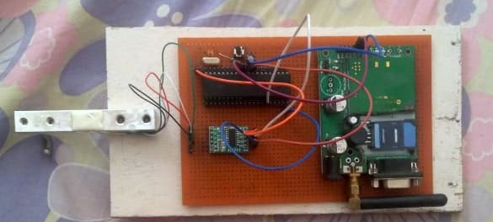

**CONCLUSION**

The smart bottle in health care employs the simple hardware mechanism to detect the content of the medical bottle through load cell, HX711 IC, microcontroller (8052) and through the reflected data from this the message which is inserted in the GSM module is sended to the registered mobile numbers. Where as in software part the interfacing of the HX711 IC and the microcontroller & GSM module and the microcontroller is coded.

**REFERENCES**

* [www.alldatasheet.com](http://www.alldatasheet.com)
* <https://www.itead.cc/hx711-dual-channel-weighing-sensor-module.html>
* <https://components101.com/wireless/sim900a-gsm-module>
* <https://www.robotshop.com/media/files/pdf/datasheet-3133.pdf>
* <https://www.youtube.com/results?search_query=gsm+working>
* <https://www.youtube.com/results?search_query=gsm+code>
* <https://www.youtube.com/watch?v=eDdASRxxeVY>